Virtual Offices
Notes:
Onboarding: https://3.basecamp.com/4291976/buckets/39628300/todos/8252623761#__recording_8310613835
Management: https://3.basecamp.com/4291976/buckets/39628300/todos/8226752345#__recording_8329436795
Passport: https://3.basecamp.com/4291976/buckets/39091663/todos/7862380180#__recording_8217099464
NexDelivery: https://3.basecamp.com/4291976/buckets/39628300/todos/8248604933
Subscription Model: https://3.basecamp.com/4291976/buckets/40985562/todos/8350388489#__recording_8350237447

Draft:
Title: New Feature - Virtual Offices

The new Virtual Offices feature is here!

This is a lengthy update so please take the time to read everything. As always, please let us know if you have any questions.

We will be hosting the training sessions next week to run through everything, but please, explore this functionality within your own account before the sessions to get some familiarity and prepare any questions you may come across.

To see the Member Portal features in your own demo nexudus account, ensure you select ‘4.0.8xx.beta’ as the portal version in the Admin Panel Settings. If your Members Portal doesn’t automatically update, you can force it to update by replacing ‘latest’ at the end of the URL with ‘4.0.8xx.beta’.

If you have any feedback for the Design team, you can leave it here: Virtual Office Feedback

This update relates to the Admin Panel and Members Portal changes. The changes to the Passport app have been designed and will be developed in the upcoming sprints.

What is a Virtual Office? A virtual office allows organisations to establish and maintain a presence in a desirable location without the need to pay for physical office space. This can include establishing a presence in different countries.

The virtual office feature offers a number of benefits to both the space operator and the customers.

Space Operator:
- The virtual office feature allows space operators to offer more services to their customers and it opens up another revenue stream for them.
- The virtual office feature allows admins to create and maintain customer contracts as well as streamline the day-to-day management of any physical mail and parcels received.

Customer:
- A virtual office allows customers to establish and maintain a presence in a desirable location without the need to pay for physical office space.
- Provides businesses with a more prestigious address than they might otherwise have if they used their actual location.
- Allows businesses to receive mail at the virtual office address, with handling options based on their preference, such as opening and scanning, forwarding, and more.

The Virtual Office feature is an additional paid service that an account owner or full unrestricted admin can enable. This can be done from the Admin Panel Settings > Your Nexudus subscription.

It is € | £ | $ 50 for 10 mailboxes per month. Each additional mailbox is an extra € | £ | $ 5 per month.

Address and Identity Checks
With this new feature, admins can manually verify customer addresses and manually or automatically verify customer identities. We offer an integration with Stripe Identity which allows admins to automate the identification check process. At the moment, we do not have an integration that allows for automatic address verification checks, however, it is something we are exploring.

Integrating Stripe Identity
Integrating Stripe Identity is straightforward:
- In the Admin Panel settings, select Integrations.
- Select the Stripe Identity integration.
- Toggle on Enable Stripe Identity.
- Enter your Stripe Publishable Key and Secret Key.
- Enable the relevant settings.
- Click Save changes.

Please consult the Stripe Identity website for their pricing.

Setting up the Virtual Office Feature
There are a few things an admin needs to do to set up the Virtual Office feature in the Admin Panel.

After subscription has been enabled, a Virtual Office plan needs to be created. This can be done manually or through the Virtual Office plan wizard template. This is the same process as creating other plans, so the steps below highlight the new fields, tabs and sections when using the Manual Entry option.

- Click the Plans tile in the Inventory module and then click + Add plan.
- Select Manual Entry.
- In the Plan Details tab, enter the plan name and enable the This plan is a virtual office plan option.
- In the Onboarding section of the Virtual Office tab:
  - Enable the relevant verification checks.
    - For the address check:
      - Enter which documents are accepted as proof and whether the check should be repeated.
Note: Currently, addresses can only be verified manually by an admin.
      - If applicable, enable the Keep contracts paused option. This will keep any VO contracts paused if the customer passes verification but their business or address is in a different country.
    - For the identity check:
      - Select whether the identity check will be completed manually by an admin or automatically through the Stripe Identity integration.
      - Enter which documents are accepted as proof and whether the check should be repeated.
  - If you’d like to ask customers additional questions during onboarding, enable the ‘Send custom onboarding form’ option and select a form from the drop-down list. See the Knowledge Base for more information on creating forms in the Community module.
- In the Delivery Handling section of the Virtual Office tab:
  - Select the delivery handling options you’d like to offer to customers purchasing this plan. By default, several options are already selected, but you can add or remove options.
  - If applicable, add charges for collecting, storing, forwarding and scanning the mail. Simply select the charge from the drop-down list. Note: You’ll need to create these charge ‘products’ in Inventory > Products before they can be added to the Virtual Office plan.
    - The Collect charge will be applied only if the customer exceeds the maximum number of free storage days
    - The Store charge will be applied to any delivery that is stored.
- In the Define section of the Virtual Office tab:
  - Enter the maximum number of company aliases, additional recipients and forwarding addresses you’ll accept in this plan.
- In the remaining tabs, enter the relevant information before clicking Save changes.

Create a VO Plan.mp4

Creating a Virtual Office Contract from the Admin Panel
From the Admin Panel, enrolling a member into a Virtual Office plan is similar to any other plan.

When a customer already has an active contract and they are signing up to a Virtual Office plan, the system will create another profile for the customer. Another profile is created as specific information is required for the Virtual Office plan, and the contact information for the Virtual Office may differ from their default profile details. For each virtual office plan a customer signs up to, the system will create another profile.

Customers with a Virtual Office profile are easily identifiable as they will have a Virtual Office tag at the top of their customer record in the Admin Panel. The Admin can easily switch between the profiles by clicking Switch profile.

Customers will be able to switch between their profiles on the Members Portal.

Virtual Office-only customers will not count towards the active user count.

You can create the contract from the Finance module or directly from the Sales tab of the customer record. See the Knowledge Base for more information on creating the contract. Once you’ve created the contract, you’ll need to re-open the record and supply some further information.

The information in the following tabs can also be supplied by the customer on the Members Portal. However, below is how an admin can input the information.

In the Contacts tab:
- Enter any additional beneficiaries and their contact details. By default, the contract owner will be added. The beneficiary’s name, email, DOB and address are required to pass identity checks. When you’ve added all of the beneficiaries, click Continue to identity checks. This will add the beneficiary's identity checks to the contract and notify the customer.
- Enter any company aliases.
- Enter any nominated recipients and their name and forwarding addresses. You can mark one as the default primary address.

Any beneficiaries added to a Virtual Office plan are required to pass identity checks if they have been enabled as part of the plan. Usually, a beneficiary would be a company director.

The nominated recipients are the people who can receive mail/parcels as part of the Virtual Office contract. They do not need to pass any identity checks. Beneficiaries can also be added as nominated recipients. It is important to note that nominated recipients cannot be made into beneficiaries after the onboarding process is complete. They can only be added if the Virtual Office plan has been set up to repeat the identity check after, e.g. 12 months.

The number of beneficiaries, company aliases and nominated recipients that can be added will depend on the limits set in the plan. The information above can also be submitted by the customer on the Members Portal.

In the Identity checks tab:
You can track the progress of the checks. You can also upload relevant documents for the recipients.

In the Delivery handling tab:
You can set the customer’s delivery handling preferences.

The contract will remain paused until all of the required beneficiaries pass the verification checks. The contract will automatically unpause once the checks have been passed.

VO Contract Admin Panel.mp4

One-off identity and address checks
Identity and verification checks happen as part of the onboarding process for a Virtual Plan. However, admins can also perform one-off checks from the Admin Panel.

This feature is available to all admins, regardless of whether the space operator has activated the Virtual Office subscription.

- Click the Identity Checks tile in the CRM module and then click + Register identity check.
- Select the customer and which checks you wish to perform: Address, Identity or Both.
- For the identity check, select the method: Manual or Stripe Identity.
Manual will be the only option for address checks at the moment.
- For the manual checks, enter which documents you’d like the customer to supply.
- Click Save changes.

The verification checks will appear in the list. From here, admins can track the progress of the check at a glance or open the record for more information. Admins can also track the progress in the Identify checks section of the CRM tab in a customer’s record.

One-off Identity Check - Create.gif

Customers will be notified of the check via email and also on the Members Portal Dashboard. From the Members Portal, they can supply the relevant documents and track the progress of the verifications. We will cover the Virtual Office feature from the customer’s perspective shortly.

If the customer has supplied the documents outside the Members Portal, the admin can upload these via the Admin Panel.

They need to open the record of the request, select the relevant tab and click Select file.
Please note that this is only possible for manual checks.

One-off Identity Check - Add Document.gif

When all the relevant information has been supplied either via the Admin Panel or Members Portal, admins will be notified. The admin can then mark the check as verified or rejected. If they are rejecting the documents, they can enter an explanation, which the customer will see on the Members Portal.

If the documents are rejected, the customer can supply the new documents either from the Members Portal, or an admin can upload the new documents via the Admin Panel.

Members Portal
Now, let’s take a look at this new feature from an end user’s perspective.

From the Members Portal, a user can sign up to a Virtual Office plan. The video below demonstrates the process a user will follow.
MP VO - Signing Up.mp4

The user can track the progress of their Virtual Office plan onboarding and their identity checks from their dashboard. If an action is required, this will be highlighted. They can also see this information in the My Activity > Identity checks section.

MP VO - Upload documents.gif

Once the user has completed the onboarding, they can manage their virtual office delivery handling preferences, company aliases and nominated recipients in the Plans and Benefits section of the Members Portal.
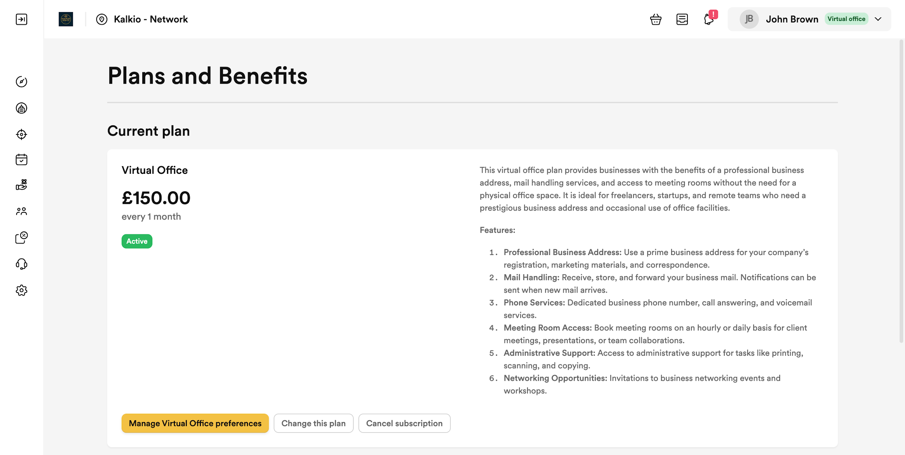

As previously mentioned, when a member has another active plan and signs up to the Virtual Office plan, another profile will be created. They can switch between their profiles by selecting their name in the top right corner and at the bottom of the list, selecting the relevant profile.

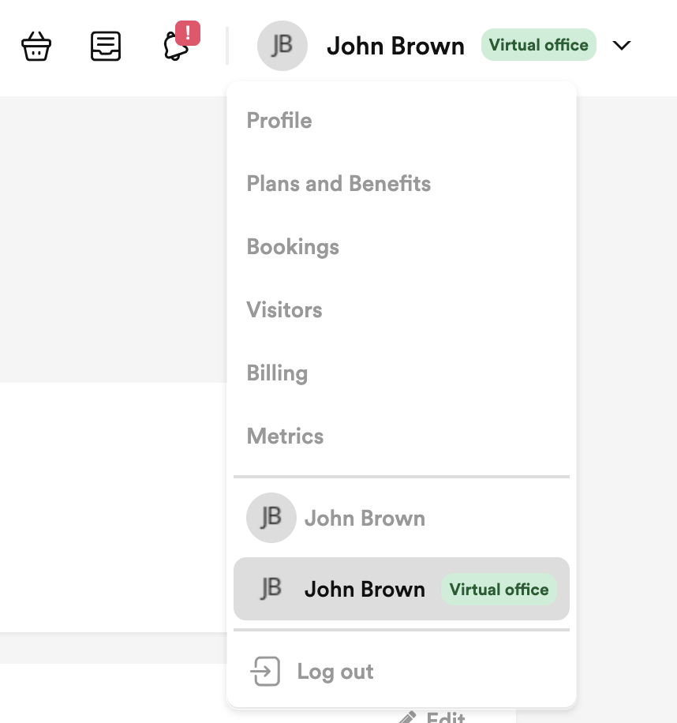

Registering a Delivery
When a delivery arrives for a Virtual Office member, admins can register the delivery in the Operations module in the Admin Panel. The core functionality of registering a delivery remains the same, however, there are some additional fields and a new layout.

You can now add a delivery type, for example, Mail or Parcel. The customer field has also been updated and you can now search for a customer or specific company. There is also a section where you can track the steps in the delivery. For example, when the parcel was received and when it was collected.

If there is a handling charge linked to the handling service, for example, a fee linked to storing, the charge will be automatically applied to the customer’s account when the ‘delivery’ is recorded. Admins can amend the charge as they register the delivery.

See the Knowledge Base for information on manually adding a delivery.

VO Delivery Charge.gif

The NexDelivery app will also be updated in due course to enhance the admin experience and make receiving mail and parcels on behalf of virtual office members easier.

